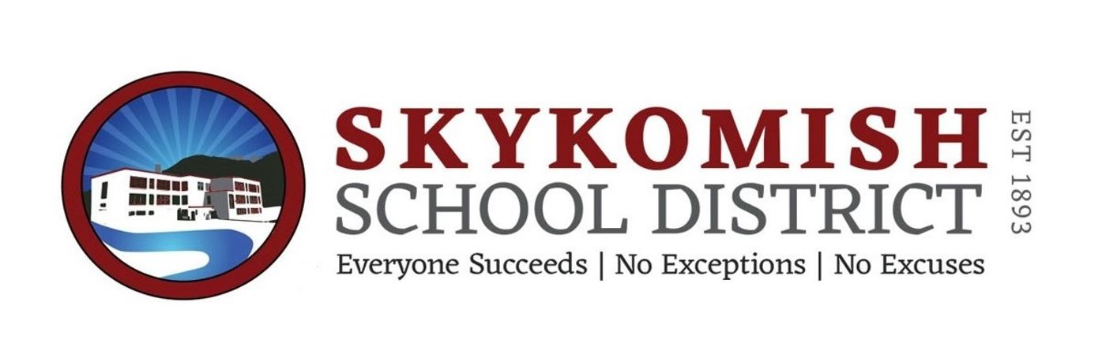

Skykomish School District #404
School Bus Driver
2019-2020 School Year
GENERAL DESCRIPTION OF A CLASSIFIED WORKER: The bus driver will work on an on-call basis under the direction and supervision of school Superintendent.
Essential Functions:
- Drives a school bus and/or other district vehicle to transport students safely to and from school for their education; transports students safely to and from field trips and other special events.
- Performs pre-trip and post-trip safety inspections of assigned bus; checks oil, water and fuel levels; checks lights, buzzers, tires, belts, brakes and other safety equipment; takes corrective act ion as appropriate to ensure safe bus operation; reports needs for bus maintenance or repair as needed.
- Maintains effective communication with students, parents, school staff and administrators, dispatchers, mechanics, other drivers and the public for safety and community relations. Promotes a positive environment for student learning.
- Observes and obeys state, local and school district laws, rules, regulations, policies and procedures related to safe driving and safe pupil transportation; conducts bus fire drills for student safety.
- Provides first aid to injured or ill students as necessary.
Other Functions:
- Maintains logs of bus activity, passenger count, mileage, fuel and other data as requested.
- Performs routine bus maintenance activities such as adding fuel, oil and fluids, and sweeping and washing the bus.
- Performs related duties consistent with the scope and intent of the position.
- Other duties as assigned.
Mental Demands:
- Requires substantial concentration in various traffic and road conditions to remain alert and responsive despite distractions from students.
- Requires decisiveness and good judgment in emergencies.
- May occasionally be required to calm distraught, angry or hostile individuals.
Physical Demands:
- Steering and braking a school bus requires strong physical condition.
- Requires prolonged sitting.
- Exposed to high noise levels from engines and students.
- Exposed to road and traffic hazards.
- Required to service buses and to drive in inclement weather.
- Frequently required to bend or twist at the neck and trunk.
- Frequently repeats the same hand, arm or finger motion many times.
- Frequently uses hand strength to grasp tools.
- Continuously driving on the job.
- Occasionally will lift and/or move up to 75 pounds, such as students.
- Specific vision abilities required by this job include close vision, color vision, and depth perception and peripheral vision.
Minimum Qualifications:
- Eligible person will be at least 21 years of age and have held a driver’s license for 5 years, with a clean driving record.
- Ability to read and follow road signs and directions.
- Ability to communicate effectively with students, parents, staff and public.
- Ability to steer, shift and brake a school bus for prolonged driving runs.
- Knowledge of laws and rules of the road.
- Ability to learn district routes, directions and schedules.
- Skill in modeling appropriate and safe behavior for students.
- Ability to instruct students in safe and responsible behavior.
- Ability to monitor and correct student behavior.
- Ability to perform routine bus maintenance and service.
- Ability to operate two-way radio and other safety equipment.
- Ability to maintain accurate, legible records and logs.
- Ability to establish and maintain effective working relationships with students, parents, school staff, transportations staff and public.
Education, License, Certification, Formal Training:
- Possession of a valid Class B, Washington Motor Vehicle Operator’s License;
- Possession of a School Bus Driver’s Certificate issued by OSPI;
- Possession of current first aid certification.
- Valid Commercial Driver’s License Physical.
Condition of Employment:
- Insurability by the District’s liability insurance carrier;
- Pre-employment drug testing (DOT);
- Random drug testing.
- Completion of yearly Safe Schools trainings.
The preceding lists of positions functions, qualifications and requirements are not exhaustive and may be supplemented as necessary

APPLICATION PROCESS:
Please submit application at https://www.skykomish.wednet.edu/departments/business-office
Human Resources, Fast Track Applications.
Skykomish School District is an Equal Opportunity Employer

