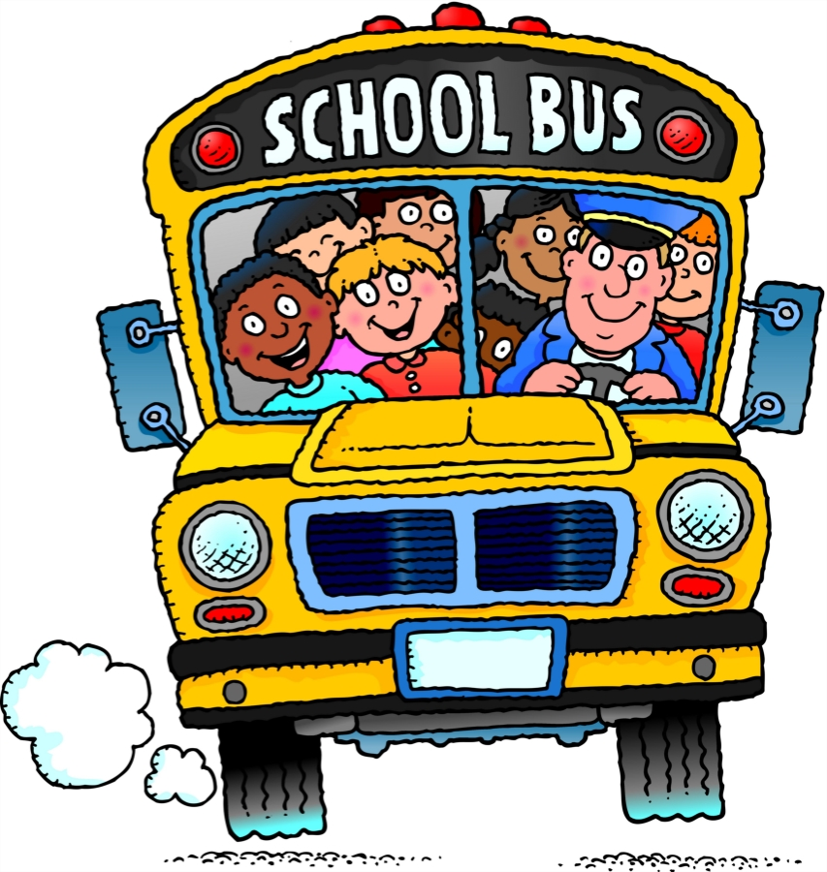
School Bus Rules
Students should be at bus stops early – at least five (5) minutes before the published time. Students must observe the District’s safety rules. Safety is the bus drivers’ and Districts’ foremost concern. Students riding the bus are expected to follow behavior rules.
- Students will obey the driver at all times
- Students will ride their assigned bus
- Students will observe classroom behavior
- Students will leave the bus at their regular stop only, unless they have a note from their parent or the office
- Students will not litter or throw items
- Students will not have food, gum or beverages on the bus without the driver’s permission
- Students will keep all body parts inside the bus
- Students will not carry hurtful items that may cause injury
- Students will stay in their seats at all times
- Students will not tamper with emergency equipment
- Students will remain quietly seated and turn off all noise-making devices at railroad crossings
- Students will keep their hands to themselves

