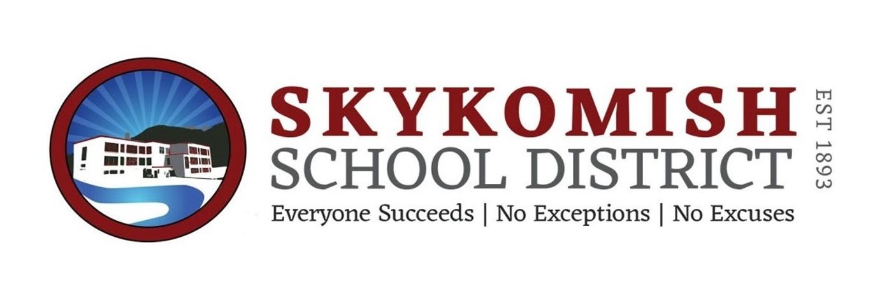

NOTICE OF GENERAL FUND
BUDGET REVISION
ADOPTION FOR
FISCAL YEAR BUDGET 2018-19
SKYKOMISH SCHOOL DISTRICT NO. 404

Notice is hereby given by the school directors of Skykomish School District No. 404, King County, Washington, that the district has completed revisions for the General Fund Budget for the 2018-19 fiscal year, a copy of which will be available on July 2, 2019 to any person who will call upon the district for the same. The board of Directors will meet for the purpose of fixing and adopting the revised General Fund budget for the 2018-19 fiscal year at a Special Board Meeting on July 24, 2019 at 6:30 p.m. at the Skykomish Community Center 114 W. Railroad Avenue.

NOTICE OF BUDGET REVISION REVIEW AND ADOPTION
By Thomas Jay
Superintendent to the Board

Published July 16, 2019
July 23, 2019

