SKYKOMISH SCHOOL DISTRICT NO. 404 KING COUNTY, WASHINGTON

NOTICE OF MEETING TO ADOPT 2021-2022 BUDGET

NOTICE is hereby given, pursuant to RCW 28A.505.050 and RCW 28A.505.060, that the Board of Directors (the "Board") of Skykomish School District No. 404, King County, Washington (the "District") will hold a regular meeting on July 28. 2021 commencing at 6:30 PM. The meeting is called for the purpose of fixing and adopting the budget of the District for the ensuing 2021-22 fiscal year. Prior to adoption of the 2021-22 budget, the Board held a public hearing for receiving comments from the public on the 2021-22 budget on July 14, 2021. The Board shall fix and determine the appropriation from each fund contained in the 2021-22 budget and shall, by resolution, adopt the 2021-22 budget, the four-year budget plan summary and the four-year enrollment projection. The 2021-22 budget information is available on the District website at http://skvkomish.wednet.edu/school-board /district-budget/ or may be obtained by contacting
Christina Daniels, Business Manager 360-677-2623 x 111.

SKYKOMISH SCHOOL DISTRICT NO. 404 KING COUNTY, WASHINGTON

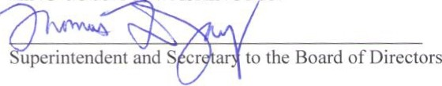

Published: July 20, 2021
July 27, 2021

